Zoom for Students

DesignPlus | Guide

# Overview

This resource is for UCI-DCE students with virtual classroom sessions (VCSs) or office hours via the Zoom LTI in their Canvas courses.

# Step 1: Download the Zoom App

For best results in your virtual classroom sessions, follow the website instructions to download the Zoom application from the [Zoom Download Center](https://ucidce.zoom.us/download).

**Note:** *The web browser client automatically will download when you start or join your first Zoom meeting. Manual download from the Download Center is recommended for first-time users.*

# Step 2: Join a Meeting

1. Log into your UCI-DCE student account (*My Account* as seen below) at <https://ce.uci.edu/>. (Also referred to as your *single sign-on*.)

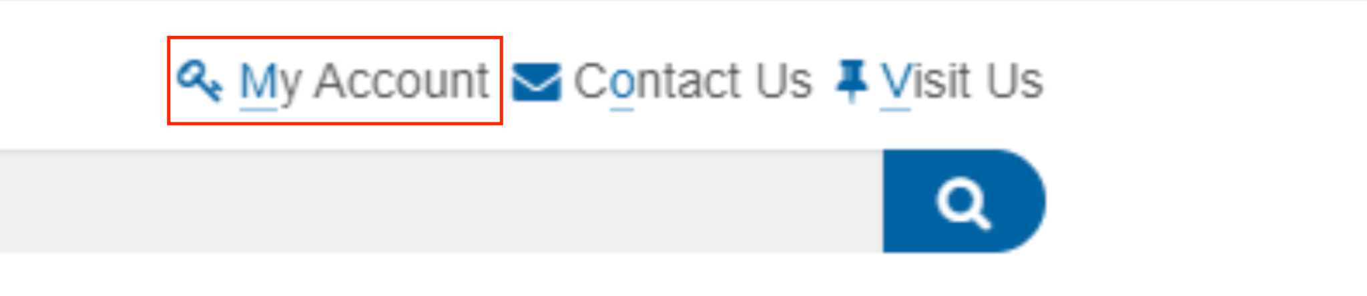

*Figure 1: My Account log in*

1. Once signed in, click on *My Course*s from the left menu bar.
2. Select *Access* *Canvas* to be redirected to your Canvas account.
3. Once in Canvas, select the course from your dashboard that your Zoom sessions are associated with.
4. Locate and click *Zoom* from your course navigation (left menu bar) within Canvas.
5. Click the *Join* button that corresponds with the virtual classroom session/office hour you’d like to join. You will be redirected to your Zoom app and signed into the session.

Zoom sessions are password protected. For users accessing Zoom through their online course, the password is included in the meeting link (URL), and users will not have to enter it.

Participants who enter the nine or 10-digit meeting ID into the Zoom app will be prompted to enter the meeting password before being allowed to join. The Zoom meeting password will be provided in the online course via the course announcements.

After you’ve joined your session, you may be placed in a waiting room until the instructor starts the meeting. This is a good time to test your audio/video. Below are additional resources to help you troubleshoot problems if needed.

* **Video:** [How to Join a Meeting](https://www.youtube.com/embed/vFhAEoCF7jg?rel=0&autoplay=1&cc_load_policy=1)
* **Resource:** [Join a Meeting](https://support.zoom.us/hc/en-us/articles/201362193-Joining-a-Meeting)
* **Resource:** [Join a Meeting by Phone](https://support.zoom.us/hc/en-us/articles/201362663-Joining-a-Meeting-by-Phone)

# Step 3: Participate in a Meeting

To effectively participate in a virtual classroom session, it's important to familiarize yourself with the available attendee controls. The explanations for each icon from left to right on the toolbar are provided below, or you can view the resource [Attendee Controls in a Meeting](https://support.zoom.us/hc/en-us/articles/200941109-Attendee-Controls-in-a-Meeting).

**Note:** *The attendee controls appear at the bottom of your screen if you're not currently screen sharing.*

Zoom participant controls

*Figure 2: Zoom participant controls*

* **Join Audio / Mute** / **Unmute**:This button allows you to connect to the meeting's audio, then once connected, mute or unmute your microphone.
  + **Audio Controls**:Click the **^** arrow next tothe *microphone* icon (**Mute** / **Unmute**) to change audio settings in the following ways:
    - Select or change the microphone or speaker that Zoom is using
    - Test your speaker & microphone (see [Testing Audio](https://support.zoom.us/hc/en-us/articles/201362283-Testing-Computer-or-Device-Audio) for more information)
    - Leave computer audio
    - Access full audio settings

*Tip*: You can also usea [Push-to-talk](https://support.zoom.us/hc/en-us/articles/360000510003) feature to unmute yourself by holding the spacebar, or use the following [keyboard shortcuts](https://support.zoom.us/hc/en-us/articles/205683899) to mute or unmute yourself.

* 1. For Windows: *Alt + A*
  2. For Mac: *Shift + Command + A*
* **Start Video** / **Stop** **Video**: This button allows you to turn your camera on or off (see [Testing Video](https://support.zoom.us/hc/en-us/articles/201362313-How-Do-I-Test-My-Video-) to test your video or for more information).
  + **Video Controls**: Click the **^** arrow next to the *video camera* icon (**Start Video** / **Stop Video**) to change video settings in the following ways:
    - Select or change cameras (if you have multiple cameras)
    - Select a [virtual background](https://support.zoom.us/hc/en-us/articles/210707503-Virtual-Background) or video filter (if enabled)
    - Access your full [video settings](https://support.zoom.us/hc/en-us/articles/201362623-About-Settings)
* **Participants:** With this feature, you can view a list of attendees and manage your participation in the following ways:
  + *Rename:* Hover over your name, and click *Rename to* change how your name is displayed to others.
  + *Non-verbal feedback icons* (if enabled by the host): Sends a notification to the host beside your name, such as *Raise Hand*, *yes/no*.
  + *Share My Pronouns/Unshare My Pronouns:* If you have [entered your pronouns in your profile](https://support.zoom.us/hc/en-us/articles/201363203), you can choose to [share or unshare your pronouns](https://support.zoom.us/hc/en-us/articles/4402698027533) in the current meeting. This feature requires Zoom version 5.7.0 or higher.
* **Chat:** Access the Chat window to chat with individual participants or the entire group. Review the complete list of functions at [Using in-meeting chat](https://support.zoom.us/hc/en-us/articles/203650445-In-Meeting-Chat).
* **Share Screen:** Start a screen share (if the host allows) to share your desktop or application. Review the resource [Screen Sharing](https://support.zoom.us/hc/en-us/articles/201362153-How-Do-I-Share-My-Screen-) for more information.
* **Record**: Start or stop a local recording. *Attendees do not have access to start a cloud recording.*
* **Reactions/Nonverbal Cues**: This interactive feature allows for quick emoji responses (clapping, thumbs-up, heart, etc.). These responses appear within a participant’s image frame. Review the complete list of functions and settings at [nonverbal feedback and meeting reactions.](https://support.zoom.us/hc/en-us/articles/115001286183)

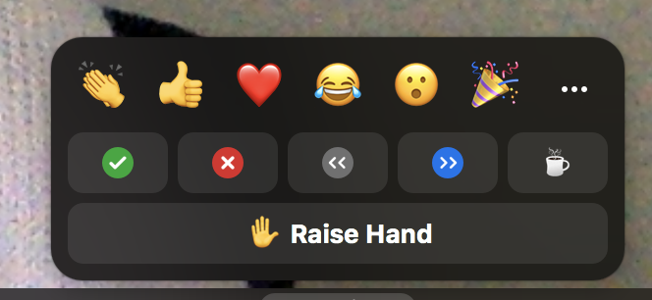

*Figure 3: Zoom reactions/non-verbal cues*

* **Closed Caption/Live Transcript:** This feature has been enabled for all UCI accounts. Participants and host can click the icon to view the closed captions or live transcripts during the session.
* **Leave Meeting:** Leave the meeting while it continues for the other participants.

# Best Practices

The following are some best practices to follow when attending a live Zoom session. Make sure to arrive early to the scheduled meeting to test connections in your environment.

## Camera & Microphone

* Test your camera and microphone before the meeting
* Position yourself by lining up your camera with your eye line
* Use a headset with a microphone to avoid echos
* Mute your microphone when not speaking; unmute before speaking

**Note:** *Attendees may be muted automatically upon entry to their Zoom session.*

## Background & Lighting

* Minimize distractions by turning off IM or email notifications that may pop up
* Alert others in the household that you will be on a video conference
* Clear background of any visual distractions or clutter

**Note:** *Students can add a virtual background to their Zoom session to make it more appealing if desired.*

* + To use the virtual background in Zoom, follow these [Zoom Virtual Background Instructions](https://support.zoom.us/hc/en-us/articles/210707503-Virtual-Background).
  + When choosing a background, determine what kind of background is appropriate for the class; a colorful/busy background might be ok for one class and not appropriate for another.
* Ensure adequate lighting for your face and background
  + Here are a few tips for [lighting your Zoom environment](https://highfive.com/blog/video-conferencing-tips-how-to-look-better-proper-lighting).

# Zoom Resources

Zoom offers additional resources to get more acquainted with this interactive tool.

* **Daily Live Demo:** Zoom offers live and interactive training sessions to become better acquainted with the available tools for anyone to attend (including students). Watch training sessions covering Zoom basics: scheduling, recording, screen sharing, and more. Multiple times available; register at [Zoom Live Training](https://zoom.us/livetraining).
* **Common Participant Issues:** Review the[Frequently Asked Questions](https://support.zoom.us/hc/en-us/articles/206175806-Frequently-Asked-Questions)
* **Custom Webinars**: Register at [Zoom Events](https://zoom.us/events) to watch webinars focused on specific topics related to Zoom usage.
* **Getting Started:** Review Zoom’s [Getting Started on Windows or Mac](https://support.zoom.us/hc/en-us/articles/201362033-Getting-Started-on-Windows-and-Mac) to help you get started using Zoom.
* **How-to Videos:** Watch video demonstrations on various topics related to Zoom usage. Review the Zoom’s [How-To Videos](https://zoom.us/resources).
* **Join a Test Meeting:** Test your internet connection by joining a test meeting on the Zoom website: [Join a Test Meeting](http://zoom.us/test).

# DCE Support

* **Instructions and FAQ:** [Zoom Live Online Class Sessions](https://ce.uci.edu/resources/events/instructions.aspx?i=zol)